

**SWINBURNE UNIVERSITY OF TECHNOLOGY**

Professional Placement: 3 Month

**Assignment 4 – Placement Reflection and Portfolio**

**NAME: TA QUANG TUNG**

**STUDENT ID: 104222196**

Please read the learning materials on Canvas Module 4 and the instructions for Assessment 4 on Canvas Assignment page to complete this assignment.

**Note**: if this is a resubmission, please see resubmission acknowledgment at the end of this document.

**SECTION 1: The introduction, scope, responsibilities and outcomes at work** (approximately 600 words)

* 1. Outline the scope of your work in placement, key projects and tasks involved.
  2. Provide a description of your role and key responsibilities of your work.
  3. Describe the key outcomes and deliverables you achieved.
  4. Briefly outline how your work contributed to a larger project or the employer’s broader activities/mission.
  5. Reflect on your initial learning intentions and what successes and challenges you encountered and any solutions that were achieved.

During my placement, my work focused on contributing to the design, development, and deployment of full-stack web applications, giving me a good understanding of how software solutions support real-world business operations and the broader mission of my host organisation.

**1.1 Scope of work**

The scope of my work primarily revolved around full-stack development using .NET for the backend and React for the frontend. I was involved in several mock projects that aimed to enhance my understanding of the company’s tech stack. One major project was the development of mentor booking platform that connected mentors and learners more efficiently. My tasks included writing backend APIs, integrating them with the frontend interface, implementing authentication features, and ensuring data security and consistency.

**1.2 Role and responsibilities**

In my role as an intern, I was expected to attend all training sessions in the first phase of the placement. In the second phase where we worked together on a mock project, my day-to-day work involved participating in daily stand-ups, sprint planning, and regular code reviews. I was expected to manage my assigned tasks independently but also to communicate proactively about progress and blockers.

A significant part of my responsibility was to ensure that any work I produced adhered to the company’s coding standards and security best practices. This meant conducting thorough testing, and writing clear commit messages. I was also encouraged to seek feedback and collaborate closely with other team members, which helped me build confidence in presenting my ideas and asking for help when needed.

**1.3 Key outcomes and deliverables**

One key outcome of my placement was my successful contribution to the mentor platform project, where my backend API endpoints and React components brought the website to life. This deliverable helped me deeply understand the company’s tech stack and familiarized me with the ways of working in a Scrum project.

**1.4 Contribution to larger projects and mission**

As the interns were not assigned real projects, I was not able to contribute much to the company’s products. However, this placement has enabled me to understand the company’s technologies and structure, knowledge that will be essential to me when I get the chance to work here as full-time employee.

**1.5 Reflection on learning intentions, successes, and challenges**

At the beginning of my placement, I set clear learning intentions: to deepen my technical skills in full-stack development, improve my time management and collaboration abilities, and gain insights to shape my future career. Looking back, I feel I succeeded in applying my academic knowledge to practical projects, learning how concepts like the MVC framework, agile principles, and secure coding practices translate into a real workplace.

One of my biggest successes was becoming comfortable with tools and workflows I had little practical experience with before, such as Azure DevOps pipelines and production deployments. I also improved my confidence in asking for help and contributing to team discussions, which was initially a challenge for me.

Time management was an area where I faced some difficulties, especially when balancing multiple tasks under tight deadlines. To address this, I used structured planning tools like Google Calendar and broke tasks into smaller parts, which helped me stay on track. Another challenge was handling unexpected changes in project requirements. I learned to be more adaptable and open-minded, seeing these changes as opportunities to develop my problem-solving skills.

**SECTION 2: Reflect on the outcomes of your Placement** (800 – 1,000 words)

Looking at the intentions for learning you set for yourself in Assignment 2, reflect on your outcomes and success across the 4 domains of WIL capabilities:

* Knowledge in Practice
* Practice of Work
* Ethical Work
* Career Development Practice

**2.1 Knowledge in Practice**

1. **What:**

In my initial intentions for learning in the Knowledge in Practice domain, I aimed to focus on full-stack web development using .NET and React, work in a collaborative team using project management tools like Jira or Azure DevOps, and gain experience publishing an application to a production environment. My academic background in software engineering provided me with foundational knowledge of object-oriented programming, database design, and agile development methodologies - concepts that were directly relevant to the work I undertook during my placement. I found tools like Jira familiar because of prior classroom exposure, but applying them in a real-world context made me appreciate how important clear user stories and task estimation are for a project’s success. One new skill I developed was deploying and maintaining a production-ready application—an area I had little exposure to at university.

1. **So what:**

This experience is highly relevant to me because it has strengthened my confidence in bridging the gap between theoretical knowledge and its application in a real work environment. It showed me that while my degree gave me a strong base, the true test is how I adapt and apply that knowledge to solve practical problems, meet deadlines, and collaborate effectively within a professional team.

1. **Now what:**

Looking ahead, there are three actions I will take to further develop my capability to apply knowledge in practice:

1. Deepen my technical expertise in areas I found challenging, such as advanced .NET configurations and more complex aspects of deployment, by completing a structured online course or certification.
2. Seek more feedback from experienced developers on my code quality and project contributions so I can identify specific habits to improve and align my work more closely with industry best practices.
3. Build my own small-scale project outside of work that incorporates a full stack, including deployment to a cloud environment, to reinforce my learning and experiment with emerging frameworks or tools that could enhance my future practice.

**2.2** **Practice of Work**

1. **What:**

My initial intention for learning in the Practice of Work domain was to improve how I manage my time, handle conflicting demands, and adapt to changes in order to complete my work to a high standard. I planned to do this by using time management tools like Google Calendar or Microsoft Teams Calendar, minimising distractions, and regularly reflecting on my progress.

During my placement, I put these intentions into practice in several ways. I started each week by blocking out work hours, task deadlines, and meetings in my calendar, which helped me stay organised and meet expectations. For example, when working on a sprint, I would break down larger tasks into smaller, manageable subtasks and update their status daily in Jira, which improved my transparency with the team. Collaboration was also a big part of my growth. I participated in daily stand-ups where I communicated my progress clearly, raised blockers when needed, and offered help when other team members faced challenges.

1. **So what:**

These work capabilities are vital for me because they don’t just help me succeed in my current placement - they are skills I will need throughout my career, no matter what role or project I take on. Good time management and task organisation allow me to deliver work that my team can rely on, while clear communication and collaboration build trust and make teamwork more effective. I also realised that being adaptable reduces stress when unexpected changes come up and helps me stay solution-focused rather than feeling overwhelmed.

1. **Now what:**

To continue building on this progress, I will take the following three actions:

1. Refine my personal productivity system by experimenting with advanced time management techniques like time blocking or the Pomodoro method to find what keeps me most focused during busy periods.
2. Seek feedback from my team on my communication and collaboration style to identify any blind spots and learn how I can better support others while managing my own workload.
3. Take on tasks that require juggling multiple priorities, such as helping coordinate small sub-projects or supporting cross-team initiatives, to strengthen my ability to adapt quickly and handle conflicting demands more confidently.

**2.3 Ethical Work**

1. **What:**

In my placement, I observed and practiced various ethical standards and professional behaviours that are vital in the tech industry. The company had clear policies on confidentiality, data security, and responsible use of information - especially when handling client data and deploying to production. Another aspect of ethical work I noticed was the emphasis on respectful communication and fairness within the team. Everyone’s ideas were given equal consideration during meetings, and it was expected that feedback would be constructive and respectful.

1. **So what:**

Learning to navigate ethical considerations is crucial because even small lapses can have serious consequences for clients, users, and the organisation’s reputation. Understanding how to handle sensitive data responsibly, communicate honestly, and make decisions that align with professional codes of conduct are all essential for building trust in my future career.

1. **Now what:**

To continue strengthening my capability in ethical work, I will:

1. Stay informed about data privacy laws and best practices, especially as technologies and regulations evolve, so that I can make responsible technical decisions in any project I work on.
2. Seek opportunities to discuss ethical scenarios with peers and mentors, to practise thinking through complex situations and understanding how experienced professionals handle them.
3. Proactively apply ethical principles in my day-to-day tasks, for example by double-checking security and privacy measures in my code, and being mindful of fairness and respect in all my workplace interactions.

**2.4 Career Development Practice**

1. **What:**

My initial intention for the Career Development Practice domain was to use this placement as an opportunity to clarify my career direction and develop a better understanding of my value in the workplace. I planned to do this by reflecting on my experiences, seeking guidance from my industry supervisor and colleagues, and attending company tech events to explore new areas and expand my professional network.

Although I was not able to maintain a detailed reflection journal due to my workload, I gained valuable insights about my strengths and interests through regular feedback conversations and by observing different roles within the team. I learned that I really enjoy the problem-solving aspect of full-stack development, especially backend design and deployment, and I found that I am comfortable working with both technical tasks and collaborative processes like code reviews and stand-ups.

Attending tech forums and presentations within the company also opened my eyes to emerging trends and specialisations I hadn’t considered before, like cloud infrastructure and DevOps. These experiences made me realise that continuous learning and upskilling will be key to staying relevant in the industry.

1. **So what:**

This learning is important because it has helped me feel more certain about the kind of work I want to pursue after graduation. Understanding my strengths and what I enjoy doing means I can make more informed decisions about future roles, training, or specialisations. It also reinforced for me that career development is not just about technical skills, but also about building relationships, seeking feedback, and being open to new opportunities.

1. **Now what:**

To further develop my capability in this area, I will:

1. Continue building my professional network by staying connected with my placement colleagues, attending industry meetups, and engaging with online tech communities.
2. Set clear career goals for the next 1–3 years, identifying the specific technical and soft skills I need to develop to achieve them—such as cloud certifications or deeper backend expertise.
3. Establish a habit of regular self-reflection, even if it’s brief, to track my growth, recognise areas for improvement, and stay aware of new career paths I might want to explore.

**SECTION 3: Professional Point of Inquiry Reflection** (approximately 300 words)

What have you learned about your Professional Point of Inquiry throughout your placement?

**What?**

Throughout my placement, I learned a lot about my Professional Point of Inquiry, which focused on how software and web development can contribute to UN Sustainability Goal 9: building resilient infrastructure, promoting sustainable industrialisation, and fostering innovation. Working on full-stack development projects exposed me to how architecture decisions—like choosing reliable frameworks, ensuring scalable database design, and following secure deployment practices—can directly impact the resilience and sustainability of digital systems.

For example, I saw firsthand how design choices like modular coding and good documentation make it easier to maintain and scale an application, which supports long-term sustainability. I also learned how teams weigh performance and cost trade-offs when selecting cloud services or setting up infrastructure pipelines, balancing immediate needs with future growth.

**So What?**

My Point of Inquiry definitely held my interest throughout my placement, and in some ways, it deepened and shifted slightly. Initially, I was mostly interested in the technical side—how architecture and frameworks contribute to system resilience. But over time, I realised that decisions about resilience and sustainability are not just technical—they are shaped by team culture, project priorities, and even organisational values. This insight helped me see that being a developer who cares about sustainable innovation means not just writing good code, but also advocating for practices that consider the long-term impact of the systems we build, and who they serve.

**Now What?**

The next steps I see for pursuing my Point of Inquiry are:

1. Deepen my understanding of sustainable software engineering practices, such as optimising performance for energy efficiency or exploring greener cloud solutions.
2. Advocate more actively for inclusive design, by learning more about accessibility standards (like WCAG) and looking for opportunities to integrate these considerations earlier in the development process.

**SECTION 4: Conclusion**

Looking back on my placement, I am proud of the progress I have made in applying my technical knowledge to real-world projects, developing stronger collaboration and time management skills, and growing my confidence as an emerging software developer. Successfully contributing to a production-ready mentoring platform and learning how to work effectively within an agile team are some of the key achievements that I will carry forward in my career.

I would like to express my sincere gratitude to NashTech Vietnam for providing such a supportive and engaging environment for my professional growth. I am especially thankful for the guidance and encouragement I received from my supervisors, mentors, and teammates, who were always willing to share their expertise and help me develop both technically and personally.

This experience has strengthened my aspiration to continue working in full-stack web development, with a focus on building scalable, sustainable systems that contribute to resilient digital infrastructure. Moving forward, I am motivated to keep expanding my skills into Cloud and DevOps, exploring emerging technologies, and seeking opportunities to build inclusive, innovative, and impactful solutions.

**SECTION 5: Appendices (Work samples (non-confidential), screenshots of work, Feedback or evaluation reports, Timeline of work)**

* Mentor Platform presentation slides, containing features implemented and testing results: <https://drive.google.com/file/d/1yF-0q32L-16Q-BWT05zjyyUWZPbMqfVX/view?usp=sharing>
* Performance appraisal:

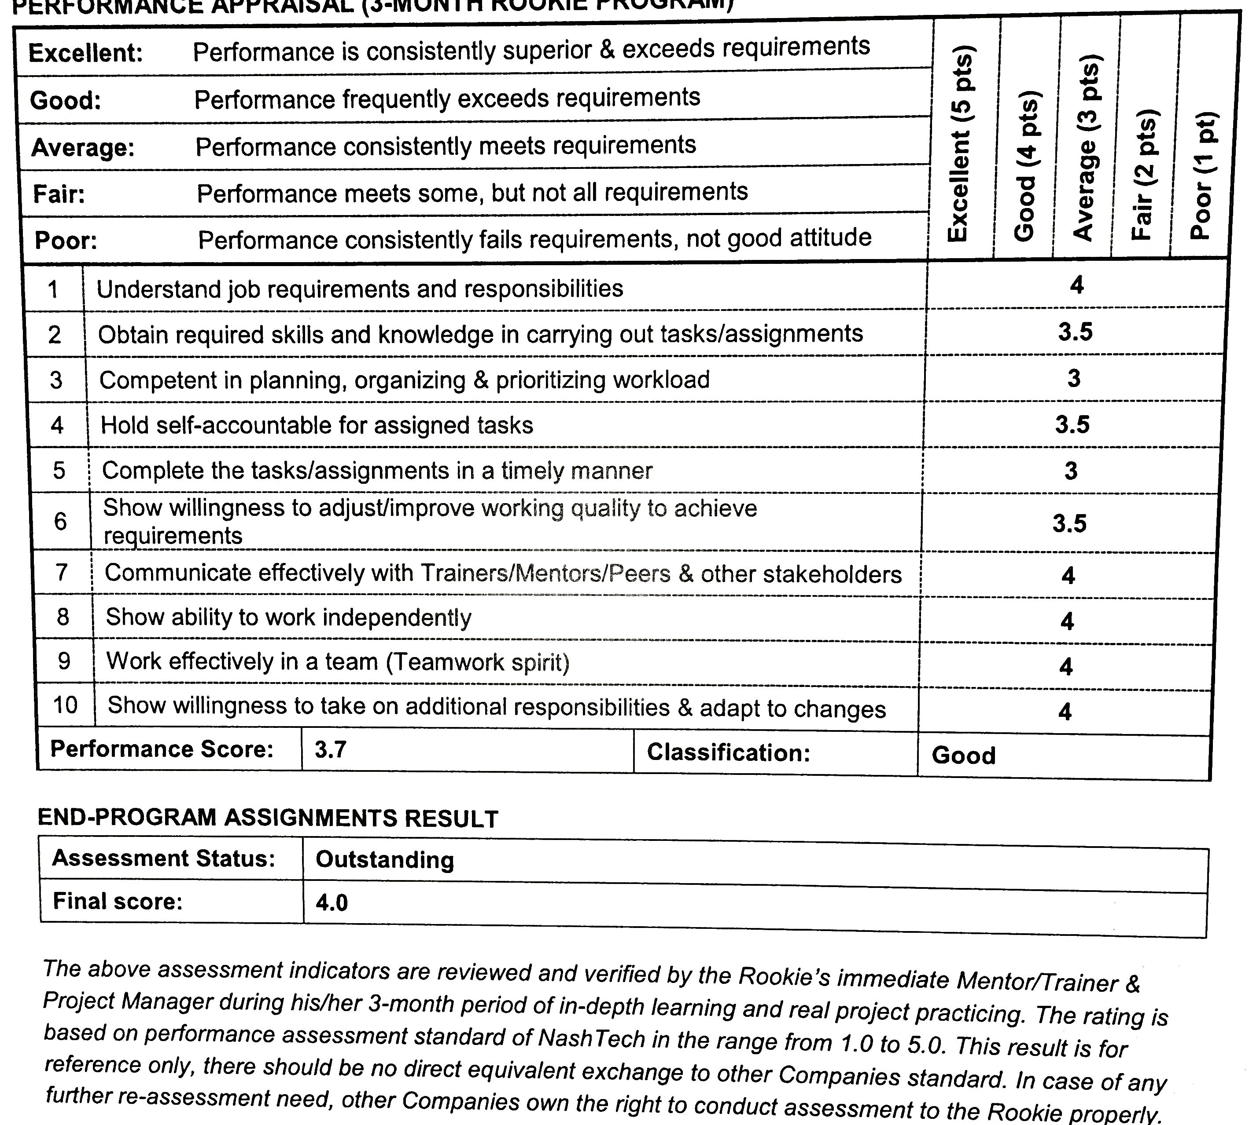

|  |
| --- |
| **Resubmission acknowledgement:** (please read and tick)  I have addressed and incorporated the feedback received. I am aware that failing to do this could result in a fail for this assignment, this has implications to passing the unit (refer to unit outline). |